**AI/ML Summer Internship**

**Task**:Image Processing and Computer Vision

As part of the AI ​​/ ML Summer internship, I received an assignment on Image Processing and Computer Vision.Before addressing the issue, I studied the required task.Before I got the problem I knew about the OpenCV library, and I tried to solve the problem with the help of that library, but in the process I realized that I had to have my own Model and I quit my job.

**What did I manage to do with the OpenCv library?**

I had reached the result that an object of green color was found in the picture, it was separated, it showed the same object in the background in the same size․

I planned to՝ get all the colors and separate them.

During the work, I researched the OpenCV library.

I started researching the problem again and realized that I needed a dataset to solve this problem.I found the dataset,so I needed it.

During my work I used the Tensorflow library.Since the dataset did not have clear labels, I labeled it first․I divided it into Train (0.8), Test (0.2) parts.For the Model I used a 2-layers neural network.The first layer has 128 neurons, I used the "ReLU" activation function.In the last layer I used the "SoftMax" activation function containing 4 neurons.I used "Adam" as the Optimizer, I used "categorical Cross entropy" as the loss function, I divided it into 5 Epochs because it already gave the desired result with 97% accuracy.I checked the accepted values ​​of the accuracy and loss function through the Matplotlib library.

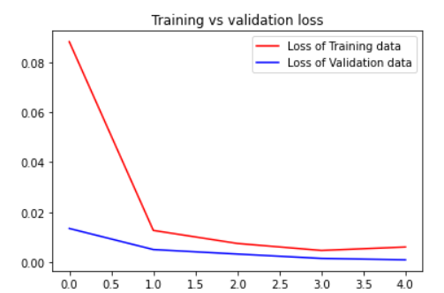

**Advantages of Model:**It is very good to study, because the data is of good quality. The accuracy is high. It does not take much time for the train.

**Disadvantages of Model.**Because I used "SoftMax" at the end, the model returns the most likely object.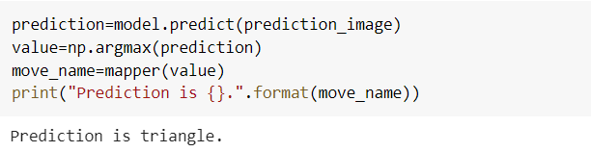

The second Model is built with several differences like the first Model.Not finding the right data for the second time, I started collecting.

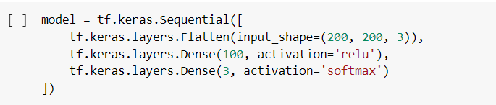

This time I used 100 neurons in the first layer.This time I used SGD (Gradient Descent With Momentum) 0.01 learning rate as an optimizer,I used "categorical Cross entropy" as the loss function.Since the data was not enough, I divided it into 10 epochs.

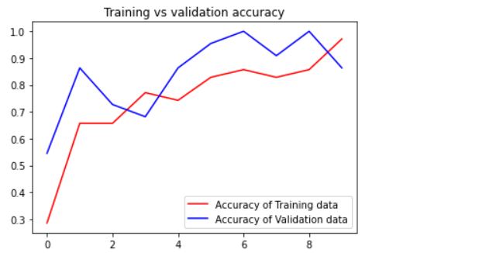

**Disadvantages of Model.**Because I used "SoftMax" at the end, the model returns the most likely object.Because there are so few color images in the data, Prediction time can cause problems.

I worked with Google Colab all the time.Work for another 4 days․

Work done by՝ 26.05.2022 / 20:30

Gevorg Karapetyan